University Students’ Perceptions, Knowledge, and Attitudes Toward Artificial Intelligence

By

Table of Contents
1. Introduction & research questions 3
1.1. Introduction 3
1.2. Research questions 3
2. Data & variables (brief description of Survey_AI) 3
3. Methods (what analyses ran per RQ) 4
3.1. Dataset 4
3.2. Software 4
3.3. Analytical Approach 4
4. Data Preparation 4
5. Results 5
5.1. AI Knowledge and Information Sources (RQ1) 5
5.1.1. AI Knowledge 5
5.1.2. Information Sources 6
5.2. Advantages and Disadvantages of AI (RQ2) 6
5.2.1. Advantage in Teaching 6
5.2.2. Advantage in Learning 7
5.2.3. Advantage in Evaluation 7
5.2.4. Disdvantage in educational process 7
5.2.5. Comparison of AI Perceptions Across Knowledge Levels 8
5.3. Demographic Influences on AI Perceptions (RQ3) 8
5.3.1. Gender 9
5.3.2. Year of Study 9
5.3.3. Major 10
5.3.4. Passed Exam 10
5.3.5. GPA 10
5.4. Relationship Between AI Knowledge, Feelings, and Academic Performance (RQ4) 10
5.5. Domains of AI Impact (RQ5) 11
5.5.1. AI Impact by Knowledge 12
5.5.2. AI Impact by Gender 12
5.5.3. AI Impact by Year of Study 12
5.5.4. AI Impact by Major 13
5.6. Students’ Perceived Utility of AI for Academic Purposes (RQ6) 13
5.6.1. Overall Utility Grade Distribution 13
5.6.2. Utility Grade Across All Groups 14
6. Conclusion 15

Introduction & research questions

Introduction
Artificial intelligence (AI) has rapidly become a central component of modern education, influencing how students learn, study, and evaluate information. As AI tools such as ChatGPT, Gemini, and automated grading systems become more accessible, understanding how students perceive and engage with AI is increasingly important for universities. This study explores university students’ knowledge, attitudes, and behaviors related to AI, with the goal of identifying patterns that can inform educational policy, curriculum design, and student support services.

Research questions
Using survey data collected from 91 students across different majors and years of study, this project investigates six key research questions:
- What is the overall level of AI knowledge among students, and where do they obtain their information?
- What advantages and disadvantages do students associate with AI in education, learning, and evaluation?
- How do demographic factors (gender, major, year of study) influence students’ perceptions of AI?
- Is there a relationship between students’ AI knowledge, feelings toward AI, and their academic performance (GPA, passed exams)?
- Which domains (education, medicine, agriculture, marketing, etc.) do students believe AI will impact most?
- How useful students perceive AI to be, and which groups find AI most suitable?
This report applies descriptive analytics and data visualization techniques using Tableau to uncover meaningful insights from the dataset.

Data & variables (brief description of Survey_AI)
The Survey_AI dataset contains responses from 91 university students and includesa structured mix of numeric, binary, and categorical variables that capture how students understand and engage with artificial intelligence. Numeric variables include self‑rated AI knowledge (AI knowledge level (1–10)), feelings toward AI (Feelings (1 to 4 scale), perceived usefulness (1- not useful at all, 10-extremely useful)), GPA (from 1 to 10 in Romania), and multiple choice of advantages and disadvantages in teaching, learning, and evaluation. Binary variables coded as 0/1 represent multi‑select items such as AI information sources (such as internet, books, social media etc) and perceived domains of AI impact (such as Education, Medicine, Agriculture, Constructions and Marketing etc). Categorical variables capture demographic information, including gender (Gender, year of study and academic major. Additional variables measure students’ perceptions of AI risks and societal effects (such as AI_dehumanization, Job_replacement, Problem_solving etc) and academic performance indicators such as passed exams. Together, these variables provide a comprehensive dataset suitable for descriptive analytics and visualization in Tableau, enabling exploration of students’ AI knowledge, attitudes, behaviors, and demographic differences.

Methods (what analyses ran per RQ)

Dataset
The dataset consists of 91 student responses and includes variables related to:
- AI knowledge (1-not informed at all, 10-extremely informed))
- AI information sources (Internet, Books/Scientific papers (physical/online format), Social media, Discussions with family/friends, I don't inform myself about AI)
- Perceived advantages and disadvantages (AI would have in the teaching process?, AI would have in the learning process?, AI would have in the evaluation process?, AI would have in the educational process?)
- Perceptions of AI risks and benefits (AI_dehumanization, Job_replacement, Problem_solving, AI_rulling_society, AI_costly, Economic_crisis and growth, Job_loss etc.)
- Feelings toward AI (Curiosity, Fear, Indifference, Trust)
- Domains of AI impact (Education, Medicine, Agriculture, Constructions, Marketing, Public administration, Art)
- Demographics (gender, major, year of study)
- Academic performance (GPA, passed exams)

Software
All analyses and visualizations were conducted using Tableau Public.

Analytical Approach
Each research question was addressed using appropriate descriptive or exploratory techniques:
Research Question | Tableau Method
Research Question | Descriptive | Comparison | Exploratory
RQ1 | X
RQ2 | X | X
RQ3 | X | X | X
RQ4 |  |  | X
RQ5 | X | X | X
RQ6 | X | X | X

Data Preparation
- Converted binary variables (0/1) to numeric fields
- Ensured all rating scales were numeric
- Created calculated fields for:
  - Percentage of students selecting each source
  - High-AI student classification
- Cleaned multi-select text fields (e.g., AIsources, Domains) using binary indicators

Results

AI Knowledge and Information Sources (RQ1)
The results show that students generally have a moderate level of AI knowledge, with most respondents rating themselves between 4 and 6 on a 10‑point scale. This suggests that AI is familiar to the majority of students, although advanced understanding remains limited. When examining where students obtain their information, the Internet emerges as the dominant source, followed by social media and academic materials such as books and papers. Only a small minority report not informing themselves about AI at all. Together, these findings indicate that students’ AI knowledge is shaped primarily by digital and informal sources, which may explain why their knowledge levels cluster around the moderate range rather than the high end of the scale.

AI Knowledge
The histogram (Figure: 5.1.1) shows a distribution of students’ self-rated AI knowledge, and the pattern reveals a strong concentration in the mid-range. The tallest bar appears in the 5.0–7.0 interval, with 34 students, indicating that the majority of respondents consider themselves to have a moderate level of AI knowledge. This suggests that most students are familiar with AI concepts but do not view themselves as highly advanced users. The next most common ranges are 4.0–5.5 (17 students) and 3.0–4.0 (15 students), showing that a substantial portion of the group rates themselves slightly below the midpoint. These clusters imply that many students have basic awareness and exposure to AI but may still be developing deeper understanding or practical skills.
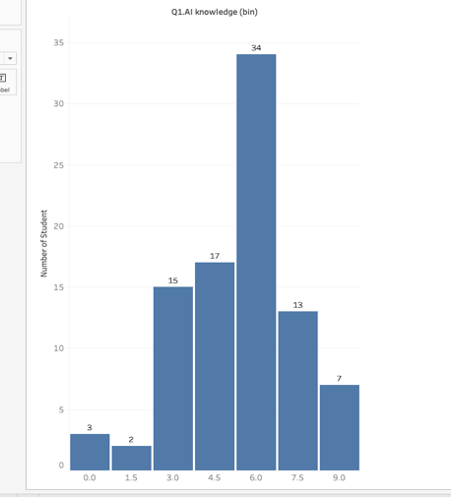
At the lower end of the scale, only 3 students fall in the 0.0–1.0 range and 2 students in the 1.0–2.0 range, meaning very few respondents feel completely unfamiliar with AI. On the higher end, the number of students gradually decreases: 13 students rate themselves between 6.0–7.0, 5 students between 7.0–8.0, and only 7 students between 8.0–9.0. This pattern shows that while some students feel confident, only a small minority consider themselves highly knowledgeable or expert-level.
Overall, the histogram forms a middle-heavy distribution, with most students clustered between 3 and 6 on the knowledge scale. This indicates that AI awareness is widespread among the student population, but advanced understanding remains limited. The distribution also suggests an opportunity for targeted AI literacy programs or skill-building workshops, especially for students in the lower ranges who may benefit from foundational support.

Figure: 5.1.1 shows how many students fall into each level of self‑rated AI knowledge

Information Sources
Figure: 5.1.2. illustrates that clear picture of where students primarily obtain their AI information and how strongly each source contributes to their learning. The percentages represent the proportion of students who selected each source and compare the relative importance of different channels. The Internet stands out overwhelmingly, with more than four-fifths of students relying on it as their main source of AI information. This dominance suggests that students prefer fast, accessible, and constantly updated online content when learning about AI. Social media appears as the second most common source, used by nearly half of the respondents, indicating that platforms such as YouTube, TikTok, and Instagram play a significant role in shaping students’ understanding of AI. Books and scientific papers are used by about one-third of students, reflecting a smaller but more academically oriented group that seeks structured or credible information. Discussions with family or friends are much less common, showing that AI is not yet a frequent topic in everyday interpersonal conversations. Finally, only a small minority of students report not informing themselves about AI at all, which reinforces the idea that AI has become a widely recognized and relevant topic among university students.
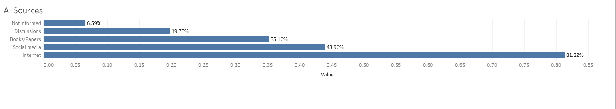

Figure: 5.1.2. shows where students primarily obtain their AI information

Advantages and Disadvantages of AI (RQ2)
AI in education is increasingly shaping how students learn, interact, and are assessed, and the survey results provide a clear snapshot of how students perceive these changes. Overall, students recognize several meaningful advantages of AI—such as greater interactivity, personalized learning, universal access to resources, and faster, more accurate evaluation—while also expressing concerns about reduced human connection, increased screen dependence, and potential disruptions to traditional learning relationships. These perceptions highlight a balanced view: students appreciate AI’s ability to enhance efficiency and support learning, yet remain cautious about its impact on social interaction and the emotional dimensions of education.
    - Advantage in Teaching
The Figure: 5.2.1. shows that students associate AI in teaching primarily with improved support and engagement. The most frequently selected advantage is the use of virtual assistants for teaching (42.86%),and also suggesting that students value AI tools that can provide immediate help, automate routine tasks, or offer explanations on demand. The second most common advantage is more interactive and engaging lessons (35.16%), indicating that students believe AI can make teaching more dynamic through multimedia content, adaptive activities, or interactive platforms. A smaller but still meaningful proportion (21.98%) selected more efficient management, reflecting the perception that AI can streamline administrative tasks such as scheduling, grading, or content organization. Overall, students see AI as a tool that enhances teaching quality by increasing interactivity and providing personalized support.
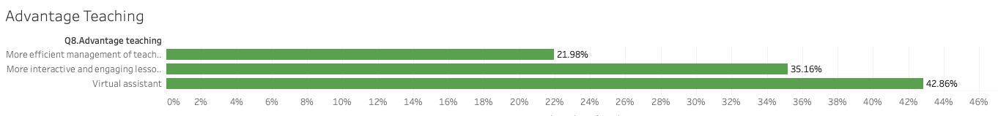

Figure: 5.2.1. shows percentage of advantage in teaching
    - Advantage in Learning
Students perceive AI as highly beneficial for learning, with the strongest endorsement for universal access (52.75%). This suggests that students appreciate AI’s ability to provide learning materials anytime and anywhere, breaking barriers related to time, location, or resource availability. The second most selected advantage is personalized lessons (29.67%), showing that many students value AI’s ability to tailor content to individual needs, learning pace, or skill level. A smaller group (17.58%) highlights more interactive and engaging learning, indicating that while interactivity is appreciated, accessibility and personalization are even more important. These results suggest that students view AI as a powerful tool for expanding learning opportunities and adapting education to individual learners .( Figure: 5.2.2)
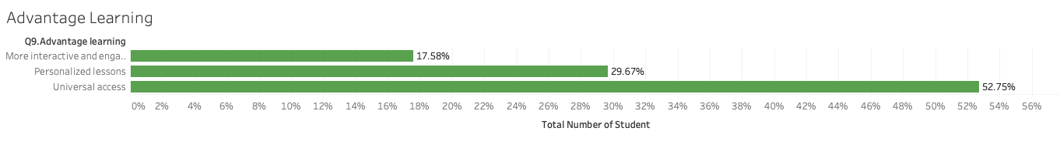

Figure: 5.2.2. shows percentage of advantage in learning

Advantage in Evaluation
Students associate AI with several improvements in evaluation processes, with the most prominent being constant feedback from virtual assistants (49.45%). This reflects a strong desire for immediate, continuous feedback that helps students understand mistakes and improve performance. The next two advantages—fewer errors in grading systems (26.37%) and automation of exam grading (24.18%)—show that students trust AI to make evaluation more accurate and efficient. These perceptions indicate that students believe AI can reduce human error, speed up grading, and provide more consistent assessment. Overall, students see AI as a way to make evaluation fairer, faster, and more supportive of learning ( Figure: 5.2.3.)
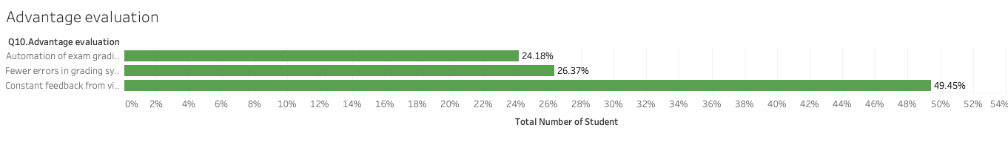

Figure: 5.2.3. shows percentage of advantage in evaluation

Disdvantage in educational process
Despite recognizing many advantages, students also express concerns about the negative impacts of AI on the educational experience. The most frequently selected disadvantage is lack of a relationship between teacher and student (37.36%), suggesting that students worry AI may reduce human interaction and weaken the emotional or motivational aspects of learning. Other concerns include internet addiction (26.37%) and rarer interactions between students (25.27%), indicating fears that AI may increase screen time and reduce social engagement. A smaller proportion (10.99%) mention loss of information caused by system errors, showing that technical reliability is a concern but not the dominant one. Overall, students’ main worries focus on the potential loss of human connection and increased dependence on technology.
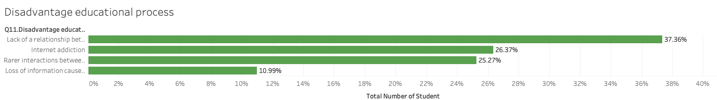

Figure: 5.2.4. shows percentage of disadvantage in educational process

Comparison of AI Perceptions Across Knowledge Levels
The combined graph shows that students with higher AI knowledge tend to select advantage options more frequently across teaching, learning, and evaluation. The upward trend in these lines indicates that as students become more familiar with AI, they are more likely to recognize its benefits—especially in learning, where the line rises the most. This suggests that knowledgeable students see AI as a tool that enhances personalization, accessibility, and engagement. Teaching and evaluation advantages also increase steadily, reflecting growing trust in AI’s ability to support instruction and assessment. In contrast, the disadvantage line remains relatively flat across all knowledge levels, showing that concerns such as reduced human interaction or increased dependence on technology do not rise with greater AI familiarity. This stability suggests that while students may acknowledge some drawbacks, these concerns are not strongly influenced by how much they know about AI. Overall, the graph reveals that higher AI knowledge is associated with stronger recognition of AI’s benefits, while perceptions of disadvantages remain consistent across groups. (figure: 5.2.5)
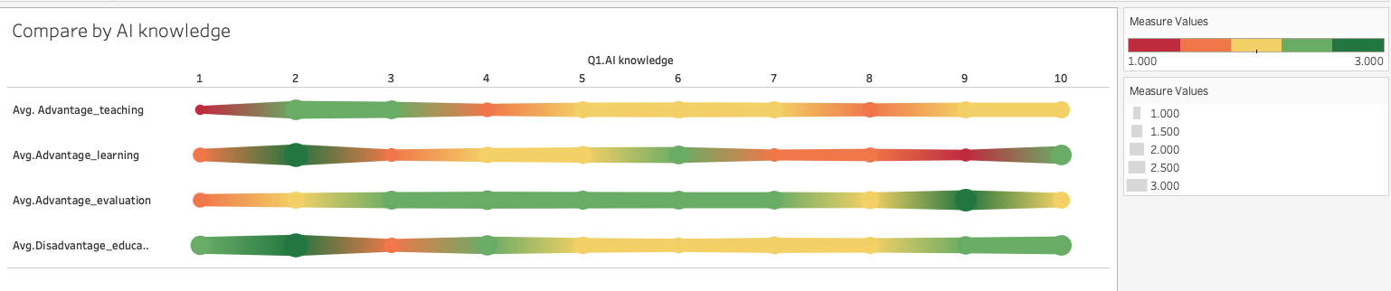

Figure: 5.2.5. shows how frequently students with different AI knowledge levels select each advantage or disadvantage option.

Demographic Influences on AI Perceptions (RQ3)
Demographic factors such as gender, year of study, major, and academic performance shape how students perceive the advantages and disadvantages of AI in education. By comparing average scores across demographic groups, clear patterns emerge that show how background characteristics influence attitudes toward AI’s role in teaching, learning, and evaluation.
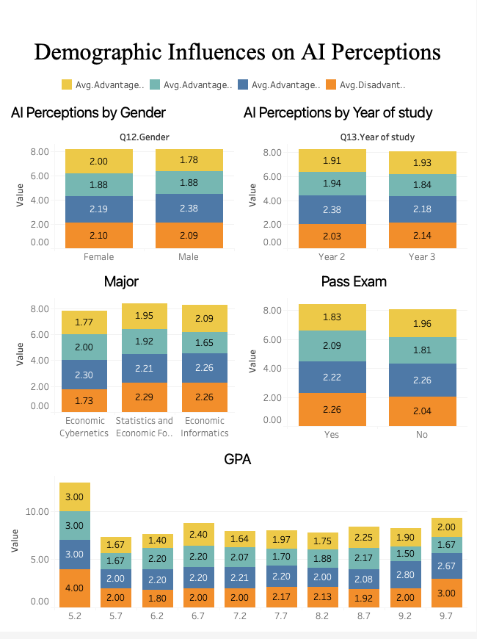
The dashboard (figure: 5.3.) shows how different demographic groups vary in their perceptions of AI’s advantages and disadvantages in education. Each stacked bar represents the average frequency with which students in each group selected teaching, learning, and evaluation advantages, as well as disadvantages. Because the variables are coded as 0/1, higher averages mean that a larger proportion of students in that demographic selected that advantage or disadvantage. The patterns across gender, year of study, major, exam performance, and GPA reveal meaningful differences in how students view AI.

Gender
Female and male students show broadly similar perceptions, but with subtle differences. Male students report slightly higher averages for teaching and evaluation advantages, suggesting they may feel more confident about AI’s ability to support structured academic tasks. Female students show a more balanced pattern, with similar advantage scores but slightly lower disadvantage scores, indicating they may perceive AI as helpful while being less concerned about negative impacts. The small differences suggest gender influences perceptions modestly rather than dramatically.

Figure: 5.3. shows demographic influences on AI perceptions dashboard

Year of Study
Second-year students consistently show higher advantage scores than third-year students, especially in evaluation. This may reflect greater enthusiasm or more recent exposure to AI tools among Year 2 students. Third-year students show slightly higher disadvantage scores, which could indicate increased awareness of AI’s limitations as they progress in their studies. The contrast suggests that academic maturity may bring more critical thinking about AI’s drawbacks, even while recognizing its benefits.

Major
Majors show the strongest demographic differences. Students in Economic Cybernetics report the lowest disadvantage score and relatively high advantage scores, indicating strong confidence in AI’s usefulness—likely because their field is closely aligned with technology and data. Students in Statistics and Economic Forecasting and Economic Informatics show higher disadvantage scores, suggesting more caution or awareness of risks. Informatics students rate teaching advantages highest, possibly because AI tools directly support their coursework. These differences highlight how disciplinary context shapes expectations and comfort with AI.

Passed Exam
Students who passed their exams show higher learning advantage scores but also higher disadvantage scores. This pattern suggests that academically successful students recognize AI’s benefits for learning but are also more aware of potential drawbacks, such as reduced human interaction or over-reliance on technology. Students who did not pass show slightly higher teaching advantage scores and lower disadvantage scores, which may reflect less critical evaluation of AI’s limitations.

GPA
GPA reveals the most varied pattern. Students with very high GPAs (e.g., 9.2) show strong advantage scores across all categories, indicating high confidence in AI’s educational value. However, some low-GPA groups (e.g., 5.2 and 5.7) also show high advantage scores but much higher disadvantage scores, suggesting mixed feelings—they appreciate AI’s benefits but feel more vulnerable to its risks. Mid-range GPA groups (6.2–8.2) show stable, moderate scores, indicating balanced perceptions. This suggests that academic performance influences both enthusiasm and caution toward AI.
To conculate, across demographics, students generally recognize AI’s advantages, but the strength of these perceptions varies. Majors and GPA show the clearest differences, with technology-aligned fields and high-performing students expressing the strongest confidence in AI.
Gender and year of study show smaller but meaningful variations. Disadvantages remain relatively stable across groups, suggesting that concerns about AI’s impact on human interaction and learning processes are shared broadly. Together, the dashboard indicates that demographic factors shape the intensity—but not the direction—of students’ perceptions, with most groups maintaining a generally positive view of AI in education.

Relationship Between AI Knowledge, Feelings, and Academic Performance (RQ4)
The bubble chart (Figure 4.4.) illustrates how students’ AI knowledge relates simultaneously to their feelings toward AI and their academic performance (GPA), with each bubble representing a group of students and its color indicating emotional attitude toward AI. The overall pattern shows that as AI knowledge increases, GPA tends to rise initially and then stabilizes, forming a curved relationship rather than a straight line. Students with low AI knowledge generally cluster at lower GPA levels, suggesting that unfamiliarity with AI may limit how effectively they use digital tools to support learning. As AI knowledge increases to moderate levels, GPA values rise, indicating that students who understand AI moderately well may be better at integrating AI tools into their study routines, leading to stronger academic outcomes. At the highest levels of AI knowledge, GPA does not continue rising sharply; instead, it levels off or dips slightly, which is common when academic performance is influenced by many factors beyond technology familiarity.
The color shading of the bubbles adds another layer: students with more positive feelings toward AI tend to appear in the mid‑to‑high AI knowledge range, suggesting that emotional acceptance of AI grows with familiarity. These students also tend to fall within the higher GPA region, implying that positive attitudes toward AI may support more effective use of AI tools for learning. In contrast, students with neutral or less positive feelings appear more scattered across the lower knowledge and lower GPA areas, indicating that emotional hesitation toward AI may be linked to limited use or lower confidence in AI‑supported learning.
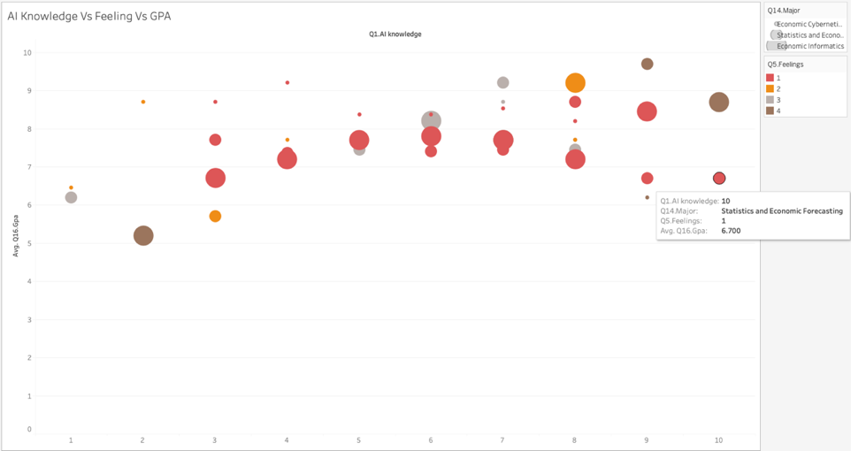
Academic major also plays a role, as shown by the bubble borders. Students in technology‑related majors cluster more tightly in the higher knowledge range, while those in other majors show more variation. This suggests that disciplinary context shapes both AI familiarity and academic outcomes, with tech‑aligned students more likely to integrate AI into their learning.

Figure: 5.4. shows relationship between AI knowledge, feelings and Academic Performance
Together, the chart suggests that AI knowledge, emotional attitudes, and academic performance are interconnected. Students who understand AI better tend to feel more positive about it, and this combination is associated with stronger academic performance, especially at moderate knowledge levels. The relationship is not purely linear, but the overall pattern indicates that familiarity and comfort with AI support more effective learning behaviors.

Domains of AI Impact (RQ5)
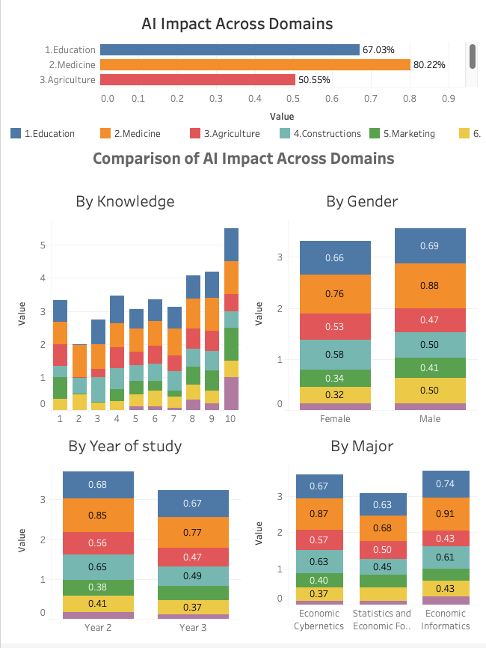
The dashboard shows that students perceive AI as having uneven impact across different sectors, with some domains benefiting far more than others. Medicine stands out as the domain with the strongest perceived impact (over 80%), suggesting that students clearly associate AI with diagnostic support, medical data analysis, and healthcare innovation. Education follows at around 67%, reflecting strong recognition of AI’s role in teaching, learning, and evaluation. Agriculture and Construction fall in the mid‑range (50–55%), indicating moderate awareness of AI’s contributions to automation, precision farming, and engineering tasks. Marketing and Administration show lower perceived impact (around 36–38%), suggesting that students may be less familiar with AI applications in communication, analytics, and organizational processes. Art is perceived as the least impacted domain (13%), showing that students still view creativity and artistic production as primarily human-driven.

AI Impact by Knowledge
The stacked bar chart across knowledge levels (1–10) shows a clear upward progression: as AI knowledge increases, students consistently select more domains where AI has an impact. At low knowledge levels (1–3), students identify only a few domains—mainly Medicine, Education, and Agriculture. As knowledge increases (4–7), students begin recognizing AI’s influence in more technical fields such as Construction and Administration. At the highest knowledge levels (8–10), students select nearly all domains, with many values reaching 1.00, meaning students with advanced AI knowledge perceive AI as impacting every domain. This pattern indicates that familiarity with AI strongly expands students’ understanding of its cross-sector applications. The more they know, the more domains they recognize as being transformed by AI.

Figure: 5.5. shows AI impact across domains

AI Impact by Gender
Both genders show similar patterns, but males consistently report slightly higher impact in Medicine and Art, while females show slightly higher impact in Agriculture and Construction. These differences are small but suggest that personal interests or academic exposure may shape how each gender perceives AI’s relevance. Overall, both groups agree that Medicine and Education are the most AI-impacted domains.

AI Impact by Year of Study
Second-year students report higher impact across almost all domains compared to third-year students. This may reflect greater enthusiasm or more recent exposure to AI topics among Year 2 students. Third-year students show slightly lower values, possibly because they evaluate AI more critically or have more domain-specific knowledge that tempers their expectations. Despite this, both years agree that Medicine and Education remain the top domains.

AI Impact by Major
Majors show the strongest differences. Students in Economic Informatics report the highest impact across most domains, especially Medicine and Education, reflecting their stronger exposure to technology and data-driven fields. Economic Cybernetics students also show high impact recognition, particularly in Agriculture and Construction. Students in Statistics and Economic Forecasting show more moderate values, especially in Construction and Marketing, suggesting a more analytical but cautious perspective. These differences highlight how academic background shapes students’ understanding of AI’s real-world applications.
To sum up, across all visualizations, the dashboard reveals that students perceive AI as having the greatest impact in Medicine and Education, with moderate influence in Agriculture and Construction, and limited influence in Marketing, Administration, and especially Art. AI knowledge plays the most powerful role: students with higher AI knowledge consistently recognize AI’s influence across more domains, suggesting that familiarity broadens awareness of AI’s capabilities. Gender and year of study show smaller variations, while academic major significantly shapes perceptions, with technology-oriented majors reporting the highest impact. Overall, the findings indicate that students see AI as a transformative force, but their recognition of its impact depends heavily on their knowledge level and academic background.

Students’ Perceived Utility of AI for Academic Purposes (RQ6)
Understanding which students find AI most useful is essential for identifying how AI can best support learning across different academic contexts. The utility grade provides a direct measure of students’ perceived usefulness of AI, allowing comparisons across AI knowledge levels, gender, year of study, and academic major. By examining these patterns together, the analysis highlights how familiarity with AI and academic background shape students’ acceptance and perceived value of AI tools in their studies.

Overall Utility Grade Distribution
The figure 5.6.1 provides a population-level view of how students rate the usefulness of AI. The distribution is heavily skewed toward the upper end of the scale, with the largest proportions of students assigning utility grades of 8, 9, and 10. Grade 10 alone accounts for more than one-fifth of all responses, and grades 7–10 collectively dominate the distribution. Lower utility grades (2–4) appear only rarely, indicating that very few students view AI as minimally useful. The color gradient reinforces this pattern: the highest counts cluster around the upper utility grades, showing that most students consistently perceive AI as beneficial for their academic tasks. This distribution aligns with the earlier graph, where groups with higher AI knowledge tended to give higher utility ratings. Together, the two visuals confirm that students overwhelmingly view AI as a valuable academic tool, and that this perception strengthens as their familiarity with AI increases.
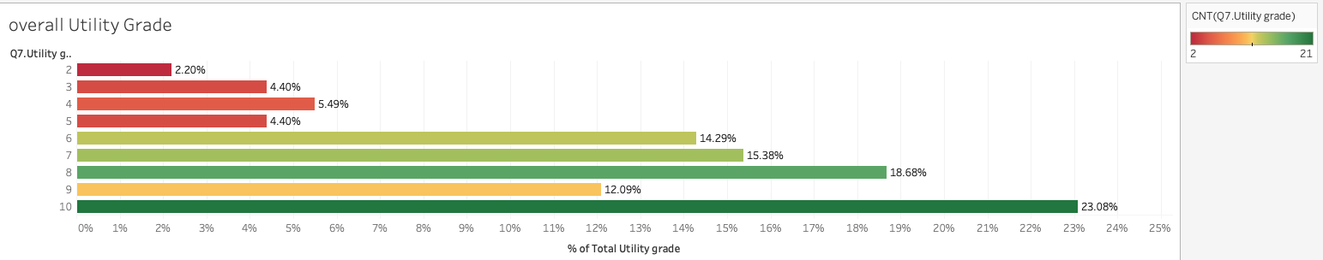

Figure: 5.6.1. shows the usefulness of AI

Utility Grade Across All Groups
The Figure: 5.6.2 shows a layered picture of how students’ perceived usefulness of AI (their utility grade) aligns with their AI knowledge and demographic background. Each row represents a unique combination of gender, year of study, and major, while the bar length and color intensity reflect the average AI knowledge within that group. A clear pattern emerges: groups with higher utility grades tend to display darker color tones, indicating higher AI knowledge. This suggests that students who understand AI more deeply are also the ones who find it most suitable for academic use. The distribution across majors reinforces this relationship. Students in technology-oriented fields such as Economic Informatics and Economic Cybernetics consistently appear in the higher-knowledge, higher-utility clusters, reflecting their greater exposure to AI tools and data-driven coursework. In contrast, students in Statistics and Economic Forecasting show more moderate knowledge levels and correspondingly moderate utility ratings. Year-of-study differences also appear: second-year students often show higher AI knowledge and utility grades than third-year students, possibly due to greater enthusiasm or more recent engagement with AI-supported learning. Gender differences are minimal, with both male and female students showing similar patterns, though males appear slightly more represented in the highest knowledge bands. Overall, the graph illustrates that AI knowledge is the strongest driver of perceived usefulness, with academic major and year of study shaping the depth of this relationship.

Figure: 5.6.2. shows utility grad across all groups
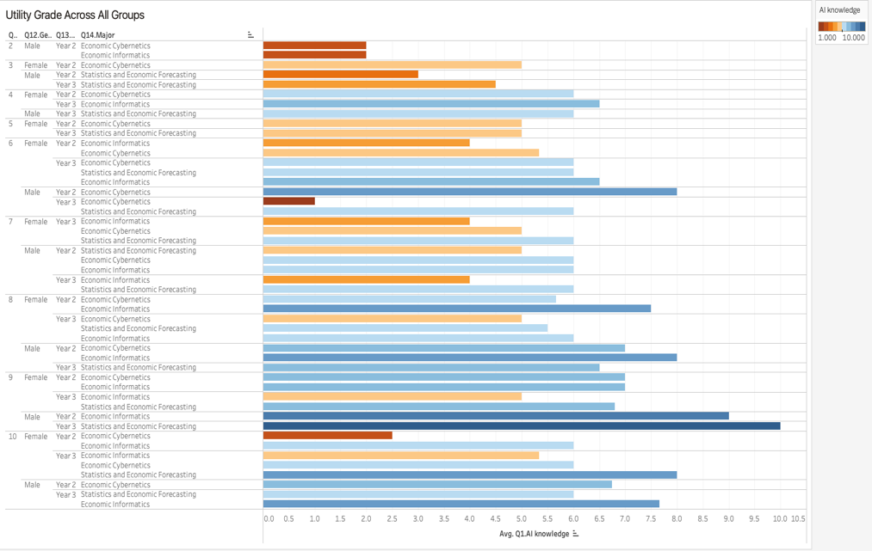
To conclude, the combined results show that students generally view AI as highly useful, with the strongest utility ratings coming from those who possess higher AI knowledge and those enrolled in technology‑oriented majors. Differences across gender and year of study are modest, suggesting that perceived usefulness is influenced more by exposure and academic context than by demographic factors. Overall, the findings indicate that AI is widely accepted as a beneficial academic resource, and its perceived suitability increases as students gain more experience and confidence in using AI technologies.

Conclusion
This study explored university students’ knowledge, perceptions, and attitudes toward artificial intelligence (AI) using survey data from 91 students across different majors and years of study. Overall, the findings show that students are generally familiar with AI and view it positively, although most rate their knowledge as moderate rather than advanced. The internet and social media are the primary sources of AI information, highlighting the strong influence of digital platforms on students’ understanding of AI.
Students recognize clear advantages of AI in education, especially in learning and evaluation, such as personalized learning, universal access to resources, and faster, more accurate feedback. At the same time, they express concerns about reduced human interaction and increased dependence on technology. These concerns are consistent across different levels of AI knowledge, suggesting shared awareness of AI’s potential drawbacks.
Differences in perception are most evident across academic majors and GPA levels, with students in technology-oriented fields and higher-performing students showing greater confidence in AI’s usefulness. Students also perceive AI as having the strongest impact in medicine and education, while areas such as marketing, public administration, and art are seen as less affected. Overall, the results indicate that students view AI as a valuable academic tool, and that increased AI knowledge is associated with greater perceived usefulness. This highlights the importance of integrating AI literacy into university education to support effective and responsible use of AI in learning.

